**NAOMH MHUIRE 2020 – JUNIOR A & C**

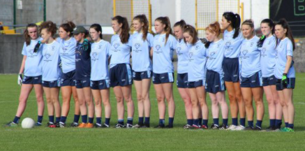

TUAM STADIUM V KILTIMAGH – CONNACHT SEMI FINAL

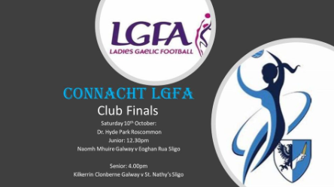







yJunior A County Final in Oughterard on 26th September 2020. Final Score: Naomh Mhuire 2-12 Salthill/Knocknacarra 2-07.

NM in Maroon & SK in White.



Galway LGFA Junior A Championship Naomh Mhuire 9-16 Caherlistrane 3-11 .

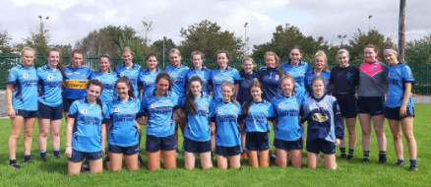

Junior C Team 2020